VAW Shelter Cleaning Checklist
Adapted from: Cleaning and Disinfecting in Client Areas Policy by SafeHaven Project for Community Living. Toronto, ON, June 2020.
Items |  | Comments
Use appropriate microfiber cloth for cleaning the corresponding surface to avoid cross contamination. (Please see Appendix 1)
Please ensure that all disinfectants are at the standard ratios for cleaning purposes.
Hands cleaned using Alcohol Based Hand Rub (ABHR) and all appropriate PPE must be used during cleaning.
Rooms and areas cleaned working from clean to dirty and high to low areas of the room.
Fresh cloth(s) used for cleaning each client’s used areas:
• if a bucket is used, do not ‘double-dip’ cloth(s)
• do not shake out cloth(s)
• if there is more than one client care area in the room, use fresh cloth(s) for each and complete the cleaning in each client care area before moving to the next
Start by cleaning doors, door handles, push plate and touched areas of frame.
Check walls for visible soiling and clean if required.
Clean light switches and thermostats.
Clean wall mounted items such as ABHR dispenser and glove box holder.
Check and remove fingerprints and soil from low level interior glass partitions, glass door panels, mirrors and windows with glass cleaner.
Clean all furnishings and horizontal surfaces in the room including chairs, window sill, television, telephone, computer keypads, night table and other tables or desks. Lift items to clean the tables. Pay particular attention to high-touch surfaces.
Clean common bathrooms/shower.
• Clean inside and outside of sink, sink faucets and mirror
• Wipe plumbing under the sink; apply disinfectant to interior of sink; ensure sufficient contact time with disinfectant; rinse sink and dry fixtures
• Clean shower/tub faucets, walls and railing, scrubbing as required to remove soap scum; inspect grout for mold; apply disinfectant to interior surfaces of shower/ tub, including soap dish, faucets and shower head; ensure sufficient contact time for disinfectant (until completely dry); rinse and wipe dry; inspect and/or replace shower curtains or as required
• Replenish paper towel, toilet paper, waste bag, soap and ABHR as required
Clean floors.
• Mop floor starting with cleanest areas and finish with the most contaminated areas last changing the clean bucket water as necessary.
• Once mopping is complete, empty the water and rinse the bucket out with warm water in the laundry room

Ensure that all high-touch surfaces are cleaned and disinfected thoroughly. (Please see Appendix 2)

Remove gloves and clean hands with ABHR. If hands are visibly soiled, wash with soap and water. Do not leave room wearing soiled gloves.

Rooms are thoroughly cleaned and disinfected with every surface wiped down once a client has left the congregate care setting

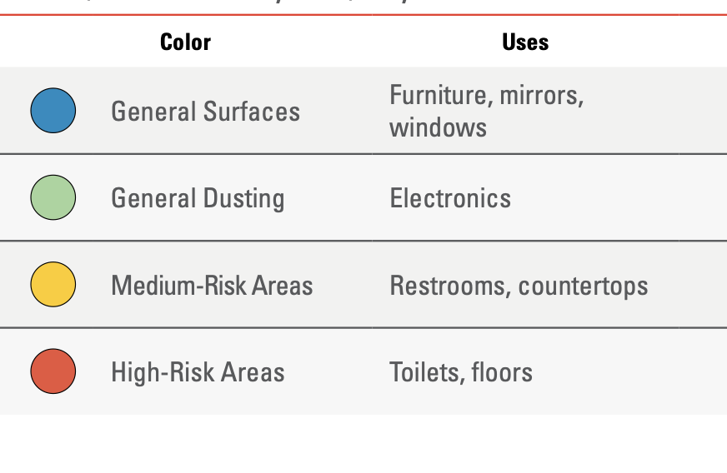
Appendix 1: Microfibre Cloth Classification
SWISH Canada Wiping and Safety Guide
Appendix 2: High Touch Surfaces
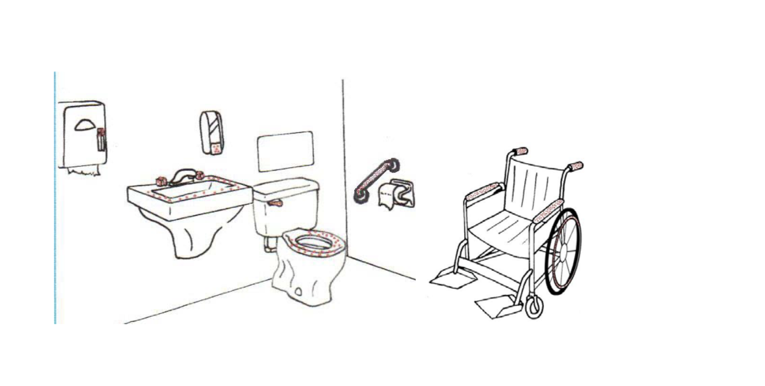
Public Health Ontario recommends paying additional attention to:
Door knobs, elevator buttons, light switches, toilet handles, countertops, touch screen surfaces (electronic), and key pads.
